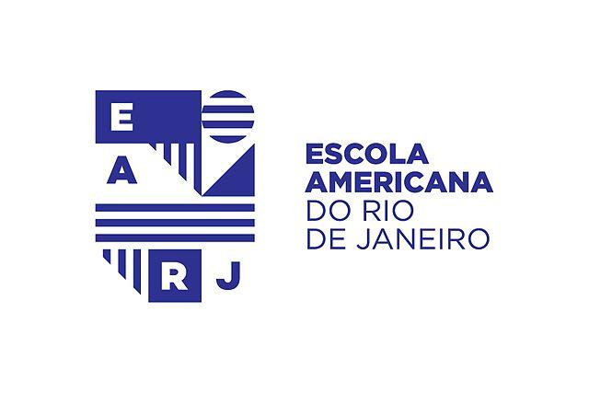

Middle School Science

Mr. Dan Schantz

**Objective**

In this class we will be using real world inquiry that will challenge your student and promote critical thinking skills in science. The emphasis on how science has a direct impact on the world around them is a theme that we will be focusing on so that as they move forward in their academic careers, they can draw on this experience to make more informed decisions regarding the world around them. This year, there will also be a push to strengthen their graphic literacy using materials sourced from American high schools.

**Grades**

I am a firm believer in data driven instruction as a means to inform me on student progress. As a corollary, I only assign grades to quizzes, tests, and projects aimed to assess content mastery of material.

**Homework**

Students will be assigned homework regularly and these assignments will serve as the basis for quizzes given the following day or later in the unit. As a general rule, I try to avoid giving weekend homework when the forecast calls for good weather.

**Class Website**

www.barrascience.com

This website will be a primary resource for the work that we do in class with links to interactive material that will enhance learning. As a parent, I encourage you to follow along so you can stay up to date on what we are learning and what this process looks like.

**Study Units**

◆ 6th Grade

◆ 7th Grade

◆ 8th Grade

|  |  |
| --- | --- |
| **Major Topic of Study** | **Specific Subjects** |
| Physical Sciences | Structure and Properties of Matter    Chemical Reactions  Forces and Interactions    Energy    Waves and Electromagnetic Radiation   |
| Life Sciences | Structure, Function, and Information Processing   Matter and Energy in Organisms and Ecosystems   Independent Relationships in Ecosystems   Growth, Development, and Reproduction of Organisms   Natural Selection and Adaptation  |
| Earth and Space Sciences | Space Systems     History of Earth     Earth’s Systems    Weather and Climate    Human Impacts    |